# Attacks on guide dogs leave blind in fear

**There have been 629 attacks since 2010**

Getty Images

* [Post a comment](http://www.thetimes.co.uk/tto/news/uk/crime/article4705130.ece#commentsStart)
* [Print](http://www.thetimes.co.uk/tto/news/uk/crime/article4705130.ece)

#### Share via

* [Facebook](https://www.facebook.com/dialog/feed?display=popup&app_id=135261079877127&link=http://www.thetimes.co.uk/tto/news/uk/crime/article4705130.ece&redirect_uri=http://www.thetimes.co.uk/includes/socialcallback.html)
* [Twitter](https://twitter.com/share?url=http://www.thetimes.co.uk/tto/news/uk/crime/article4705130.ece&text=Attacks%20on%20guide%20dogs%20leave%20blind%20in%20fear)
* [Google+](https://plus.google.com/share?url=http://www.thetimes.co.uk/tto/news/uk/crime/article4705130.ece)
* 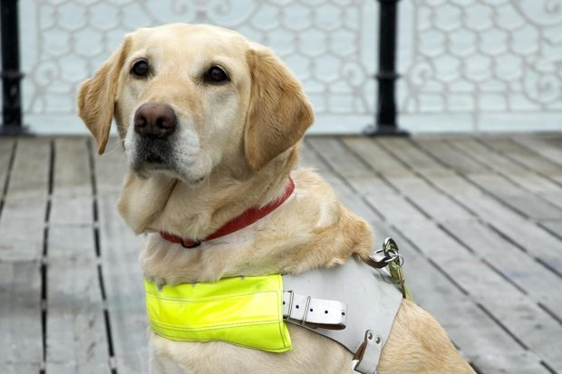

**There have been 629 attacks since 2010**Getty Images

**Katie Gibbons**

Last updated at 12:01AM, March 4 2016

Attacks on guide dogs by other dogs have soared in the past five years despite the introduction of a new law that can send owners to jail.

Blind or partially sighted people reported more than three times the number of attacks last year than in 2010, largely due to a rise in “status dogs” and irresponsible owners, experts said. Many guide dogs, which are castrated at birth and trained to be passive, are forced to retire.

There was an increase from an average of three attacks per month in 2010 to 11 per month in 2015, costing Guide Dogs, the UK charity and provider of dogs to blind people, more than £650,000. There were 629 attacks reported between 2010 and 2015.

Researchers from the charity and the University of Nottingham examined data on all dog attacks on their 8,000 working stock and found that 97 per cent of attacks occurred in public areas. Almost 20 per cent of qualified guide dogs were unable to work for a period of time and 20 dogs were permanently withdrawn. In March 2014, the Anti-social Behaviour, Crime and Policing Act was passed making an attack on a guide dog an aggravated offence, punishable by three years in prison for the owner, yet some police forces seem unaware that an attack on a guide dog should be treated differently from an ordinary dog fight.

Eve Riches, 42, a teacher from Chelmsford, was left traumatised when her guide dog Jet was attacked by a husky as they walked home from work last month. “I could hear the husky growling. It went for Jet, who was crying. I was screaming and crying but the owner wasn’t there . . . I ran into the road and flagged down a bus. I thought Jet was going to be killed,” she said.

When she reported the incident to police it was initially treated as an ordinary dog attack and no criminal investigation was started. “I have an active social life [and] full-time job but this attack has made me nervous,” she said. “It was the third attack on Jet in eight weeks. I can do more with a dog than a long stick, but it is making me not want to have a guide dog.”